Why datamerge?
If you want to create a number of documents with the same layout but different content, it may be easier and less time-consuming to create a template in Illustrator and then “fill” in the placeholders with data from another source. A good example of this would be if you were doing 100 name tags, and each name tag had the same layout, with a background image, logo and border, but a different name and photo. You would create the template with the background image, border and a placeholder name and image. Then you would datamerge in the names and images to create 100 individualised name tags.

Illustrator and InDesign both datamerge documents. InDesign will datamerge into one document, whereas Illustrator is a little more complex and will datamerge individual datasets and you then have to batch process the result into separate documents which are exported as PDF files. This is because Illustrator does not do “multipage” documents like InDesign does. Both processes have their advantages and disadvantages.
I will take you through both processes and you can choose which software you prefer and which suits you best. If you want separate files for each output, then Illustrator will be best. If you want one file that contains all the documents, then InDesign is best.

Skills you should have before starting this:
- Be confident using a spreadsheet to enter information (no formulae required)
- Save a spreadsheet as a .csv file
- Work with text and images in InDesign
- Creating paragraph styles in InDesign

InDesign Datamerge:
These are the steps that I will take you through:
Steps:
- Create template
- Create datasource
- Select the data source
- Insert the fileds into the target document
- Preview and check the documents
- Merge and save

1.Create template
You need a template for your design before you start. The template will have the elements of your final document that are both constant (will stay the same across all documents) and dynamic (will change in each document).
Each element of your document that is dynamic will need to have a corresponding element in the data source. You need to make sure that when you are creating your template, you are thinking about the information that is going to go into the final document, and making sure that you take note of what needs to go into your data source document to populate your final document.
A template in this instance is just a new document.
File > New Document.
Select Print from the options along the top, then View all Presets to get A4, A3 etc. or type in your dimensions for a custom size. InDesign will create a CMYK workspace by default when you choose Print as your document option, so you don’t need to worry about your colour profile.
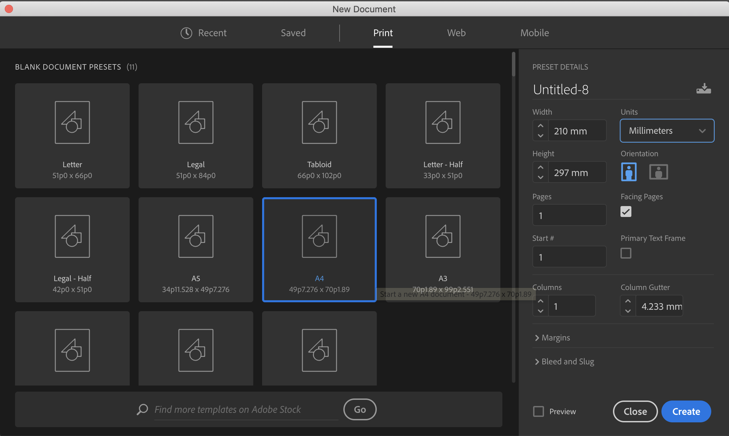

Your students will go through the design process and get to a final design from which they will create a template (or their final design will become their template if their design process is digital). Images will be place-holders, and textboxes will be set up with paragraph styles and dummy text.
Anything that is constant on each document can be created and put into the template.
For example, on the template below, the “Contact Us” is the same on every document, and the brown and black panels are the same on every document. The rest of the text is dummy text, with paragraph styles created and applied.
Once you have created your document, go to File > Save As and choose Template from the Format dropdown menu.
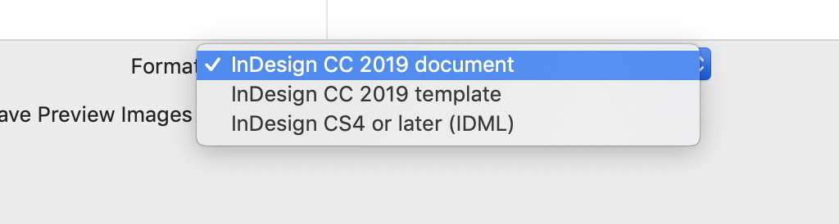
2.Create data source
The source file contains the data and images that will go into your documents. For the purpose of this example, I am creating a spreadsheet, and saving it as a .csv file. You can do an XML file as well, but I prefer to use a .csv file. To create a .csv file, just make a spreadsheet (Excel or Googlesheets will both work) and Save as (Excel) or Download as (Googlesheets) .csv (comma separated values).

Your spreadsheet needs to have headings in cells across the top that will correspond to any fields/placeholders in your template.
For example, if you have three text boxes that need text filled in your template, you will have three columns in your spreadsheet, appropriately named according to the text they contain.
Eg “companyName”, “companyAddress”, “smallBlurb”
For any images, you need to have the full filepath typed into the cell. The filepath is the place or location of the image file on your computer. It tells Indesign where to find the image on your computer, what folder it is saved in, where it is located and what it is called.
Image columns must start with the @ symbol eg. @mainImage. Most spreadsheet applications also require you to have a single quote in front of the @ symbol. So your heading for an image would be ‘@mainImag
InDesign will show you what the filepath is for your images. (see screenshot below) Go to File > Place and place an image from the same folder that you are keeping all your assets in. Then go to Window > Links and it will show you the links panel. InDesign will allow you to copy and paste the full file path. Don’t worry about getting the data to look good in the template before putting it into the spreadsheet. That defeats the whole purpose of the data merge. Once you have the data put into the data source, and you create the data merge, you can preview each dataset individually before you actually make the final merge. This final step means that you can go back and make any changes to your layout and information before committing to the data merge and exporting your files. You can re-link your data source at any time, which means that you can make changes to the amount of text in there, save it and re-link, then do the data merge again and preview the data sets before committing to the final data merge and exporting the files.

If you are typing text in InDesign and then copying and pasting into Excel, wherever you have a return or enter, Excel will put the text into a new cell. You don’t want this to happen, so either type your info straight into the Excel document, or copy it from InDesign, then click on the cell you are pasting it into, press F2 (or fn F2 if you have a Mac) and then Ctrl-v or Cmd-v to paste. By using function F2, Excel will put all of the text into just one cell. Or just paste directly into the formula bar and you avoid the issue.

Your data source needs to be a .csv file, and it needs to be saved and then closed before you start your data merge. InDesign will not do a data merge if the .csv file is open. You need to ensure there are no empty columns in your data source, and that your images have the full file path typed in, with the @symbol at the beginning of any image header name to show that it is a graphic.

InDesign filepath for images:
copy full filepath from the links panel (Window > Links):
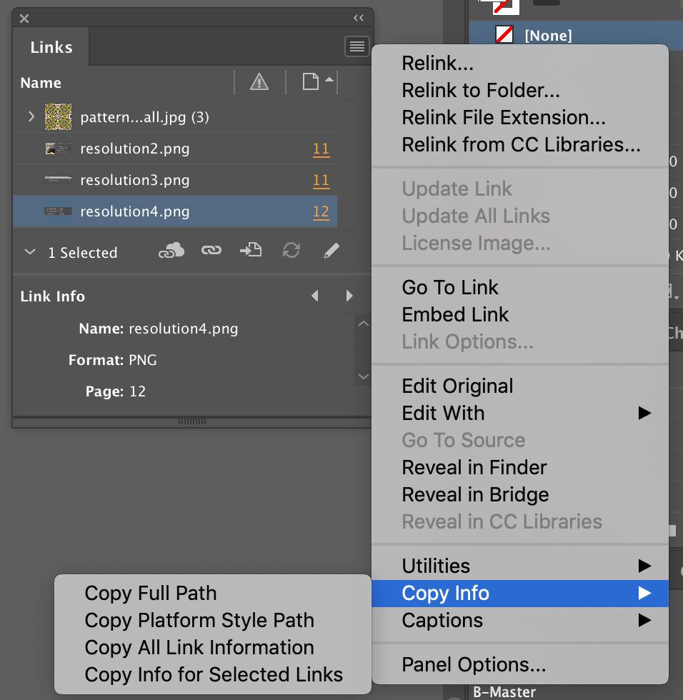

With InDesign, you don’t need to have an image in the template, you can just have a placeholder frame, or a rectangle frame.
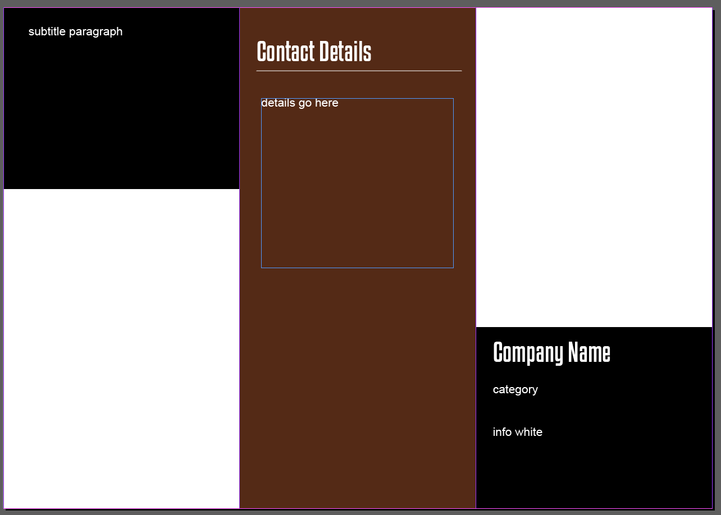

Go to Window > Utilities > Datamerge and you will get the following dialog box:
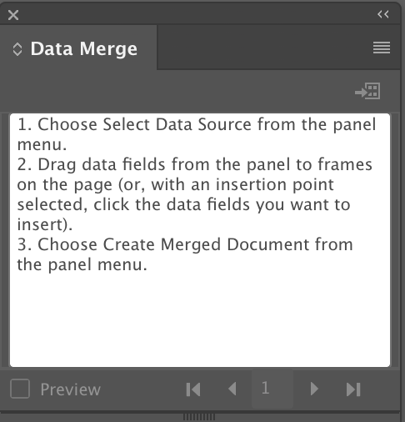

Click on the submenu (the 4 lines in the top right hand corner) and Select Data Source. Choose your .csv file, and your data will appear in the dialog box.
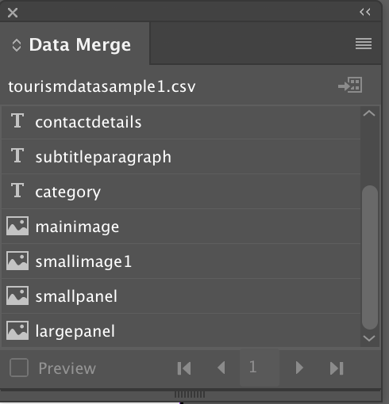
Click on the data source in the data merge dialog box and drag the data source into the frame or text box that is associated with it in the template, and you will get the name of the data with two << >> brackets to show that the placeholder is there. Any image placeholder will have a dashed blue line to show that the data is ready to be inserted. Do not drag a variable into any textbox or image frame that you don’t want to change (for example, the words “Contact Details” and the black boxes in the background of this image).
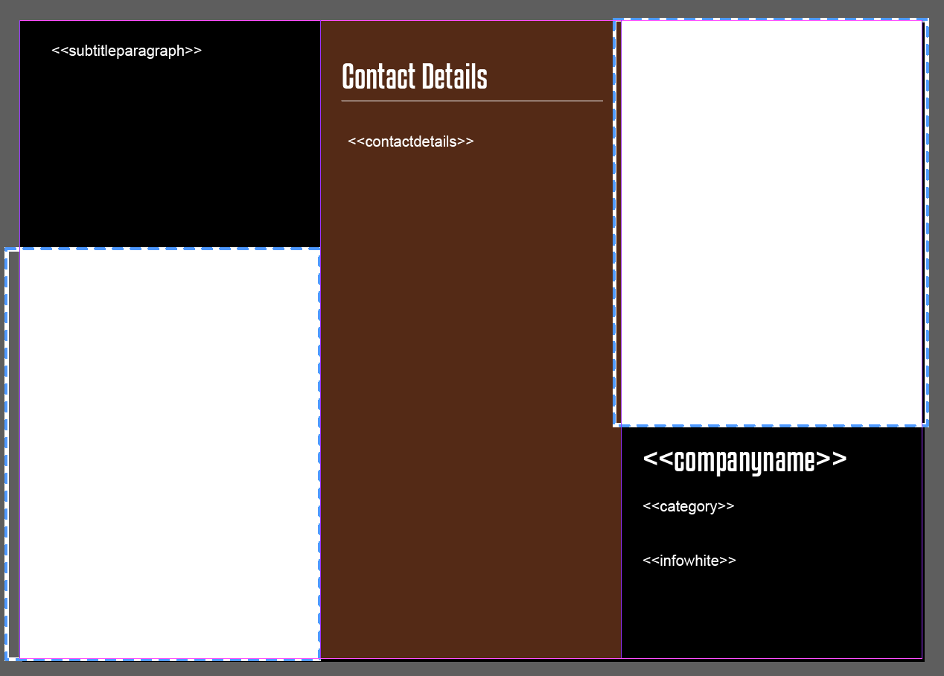
Now preview your document before you merge it by clicking in the preview box at the bottom of the datamerge dialog box. You can use the forward and back arrows to scroll through all the documents that the merge will create once you’re ready to go. Any changes that need to be made to the template need to be done now, before you merge.

Deselect the preview button, make your changes, preview again, and make sure you’re ready to merge.

When you are certain that your document is ready save your template.

Now, go to the submenu of the dialog box and choose Create Merged Document. This will bring up another dialog box. Depending on the type of document you are creating, you will need to go through the different options and choose what best suits your document. For this example, it’s a single record per page, so I just click on OK.
InDesign generates a new document, with each page being a separate version of the document I originally created. IF there is any text that doesn’t fit inside your text boxes, you will get a message telling you which page this occurred on, so you can go and fix it.
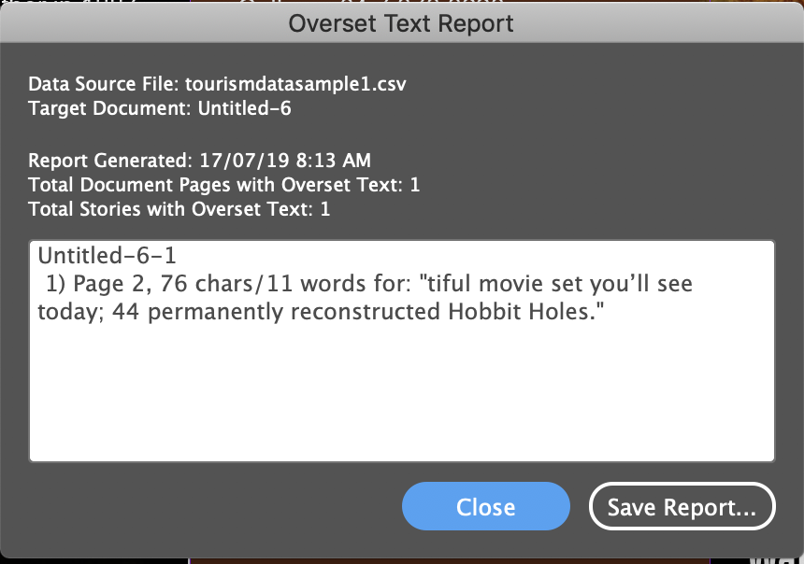
Just press Close, and either make the text box bigger, delete some of the text, or adjust the paragraph style to make the font slightly smaller.

Save your new document.

https://helpx.adobe.com/indesign/using/data-merge.html#Prerequisites

